Template for Evidence(s)
UI GreenMetric Questionnaire

University : ...
Country : ...
Web Address : …

[3] Waste (WS)
SAMPLE

[3.4] Program to Reduce the Use of Paper and Plastic on Campus (WS.2)

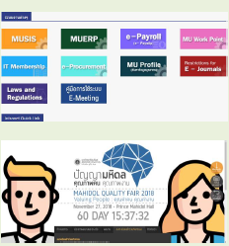 | 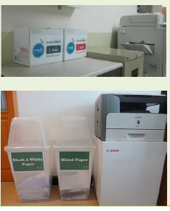
1 | 2
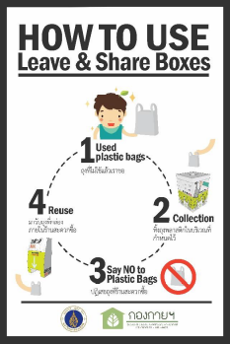 | 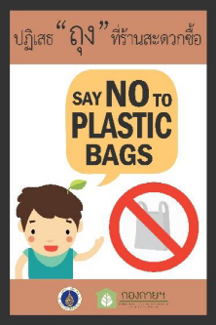
3 | 4
Example of Program to Reduce the Use of Paper and Plastic in Campus (Mahidol University, Thailand)

Description:
(Please describe the program to reduce the use of paper and plastic on your campus. The following is an example of the description. You can describe more related items if needed.)
- Mahidol IT supports paperless system to reduce paper in daily workplace. It can reduce a lot of paper use that mean Mahidol University can reduce CO2 emissions and save the world.
- Solutions of reusable paper in back office, e.g. using 2-side of paper, always recheck your data before print, use online system instead of hard copy.
- Mahidol University has a policy of “Reduce Reuse plastic bag in the last 3 years. We can reduce around 3 million bags per year or reduce 90% of plastic waste in university”.
"Mahidol Reduce & Reuse Plastic Bag" project is consistent with the campaign's key points of United Nations Environment Program (UNEP) this year focused its campaign on "Waste Plastic Pollution" (Beat Plastic Pollution) is the same direction around the world as “if you cannot reuse it, refuse it".

Additional evidence link (i.e., for videos, more images, or other files that are not included in this file):

